.
.
Contents
2. DEVICE DESCRIPTION & PRODUCT SPECIFICATION, INCLUDING VARIANTS & ACCESSORIES 2
2.1 Descriptive information for the device 2

.
.

2. DEVICE DESCRIPTION & PRODUCT SPECIFICATION, INCLUDING VARIANTS & ACCESSORIES

2.1 Descriptive information for the device
(a) Device Description

The -86 Ultra Low Temperature Freezer is intended for the storage of Frozen Red Blood Cells in 40% Glycerol at –65°C for up to 10 years; Frozen Rejuvenated Red Blood Cells at –65°C for up to 10 years; Fresh Frozen Plasma at –65°C for up to 10 years. These products are suitable for Vaccine and Pharmaceutical Storage when –50°C to –86°C is determined as an acceptable storage condition. These products should only be used by an authorized and adequately trained personnel.
Table 5: Device Information
Generic Name | Model Name | Model No.
Storage Freezer for Blood, Plasma, Tissue, Skin, and Bone | Thermo Scientific -86 Ultra Low temperature Freezer | TDE30086LA
Storage Freezer for Blood, Plasma, Tissue, Skin, and Bone | Thermo Scientific -86 Ultra Low temperature Freezer | TDE30086LD
Storage Freezer for Blood, Plasma, Tissue, Skin, and Bone | Thermo Scientific -86 Ultra Low temperature Freezer | TDE30086LV
Storage Freezer for Blood, Plasma, Tissue, Skin, and Bone | Thermo Scientific -86 Ultra Low temperature Freezer | TDE40086LA
Storage Freezer for Blood, Plasma, Tissue, Skin, and Bone | Thermo Scientific -86 Ultra Low temperature Freezer | TDE40086LD
Storage Freezer for Blood, Plasma, Tissue, Skin, and Bone | Thermo Scientific -86 Ultra Low temperature Freezer | TDE40086LV
Storage Freezer for Blood, Plasma, Tissue, Skin, and Bone | Thermo Scientific -86 Ultra Low temperature Freezer | TDE50086LA
Storage Freezer for Blood, Plasma, Tissue, Skin, and Bone | Thermo Scientific -86 Ultra Low temperature Freezer | TDE50086LD
Storage Freezer for Blood, Plasma, Tissue, Skin, and Bone | Thermo Scientific -86 Ultra Low temperature Freezer | TDE50086LV
Storage Freezer for Blood, Plasma, Tissue, Skin, and Bone | Thermo Scientific -86 Ultra Low temperature Freezer | TDE60086LA
Storage Freezer for Blood, Plasma, Tissue, Skin, and Bone | Thermo Scientific -86 Ultra Low temperature Freezer | TDE60086LD
Storage Freezer for Blood, Plasma, Tissue, Skin, and Bone | Thermo Scientific -86 Ultra Low temperature Freezer | TDE60086LV

Materials of Construction:

- The cabinet is constructed of cold rolled steel (CRS), 20GA, painted for corrosion protection.
- The cabinet is constructed of 22GA CRS, painted for corrosion protection.
- The cabinet is constructed of 22GA stainless steel.
- The cabinet is constructed of 14GA CRS or HRS, painted for corrosion protection.
- The cabinet is constructed of fiberglass reinforced plastic.
- The foam used for thermal insulation is polyurethane foam.
- The casters are constructed with 2” dual wheel construction.
- The pilaster is constructed of aluminum (0.032”).
- The shelf support is constructed of stainless steel.
- The breaker is constructed of Makrolon ET3227.
- The breaker is constructed of Lexan PCEXL1414.
- The gasket is made of FDA silicone blended with phenyl silicone.
- The deck side panel is constructed of 20GA CRS, painted for corrosion protection.
- The front filter panel is constructed of CRS, 18GA, painted for corrosion protection.
- The front frame is constructed of 18GA CRS, painted for corrosion protection.
- The rear grille is constructed of 18GA CRS, painted for corrosion protection.
- The door is constructed of 18GA CRS, painted for corrosion protection.
- The inner cabinet is constructed of 22GA CRS, painted for corrosion protection.
- The inner cabinet is constructed of 22GA stainless steel.
- The shelf is constructed of 22GA stainless steel.
- The door liner is constructed of fiberglass reinforced plastic.
- The refrigeration control – capillary tube is made of copper.
- The heater is constructed using AWM Style 1015 and 3323 wire.
The –86°C Freezers (refer to Models for the specific model series) described in this manual are intended for the storage of Frozen Red Blood Cells in 40% Glycerol at –65°C for up to 10 years; Frozen Rejuvenated Red Blood Cells at –65°C for up to 10 years; Fresh Frozen Plasma at –65°C for up to 10 years. These products are suitable for Vaccine and Pharmaceutical Storage when –50°C to –86°C is determined as an acceptable storage condition. These products should only be used by an authorized and adequately trained personnel. This unit is not intended for use in classified hazardous locations, nor to be used for the storage of flammable inventory.
Indications:
No Indications are defined in the Installation and Operation manual. The –86°C Freezers described in this manual are intended for the storage of Frozen Red Blood Cells in 40% Glycerol at –65°C for up to 10 years; Frozen Rejuvenated Red Blood Cells at –65°C for up to 10 years; Fresh Frozen Plasma at –65°C for up to 10 years. These products are suitable for Vaccine and Pharmaceutical Storage when –50°C to –86°C is determined as an acceptable storage condition. These products should only be used by authorized and adequately trained personnel. This unit is not intended for use in classified hazardous locations, nor to be used for the storage of flammable inventory.
Instructions for Use:
The –86°C Freezers (refer to Models for the specific model series) described in this manual are intended for the storage of Frozen Red Blood Cells in 40% Glycerol at –65°C for up to 10 years; Frozen Rejuvenated Red Blood Cells at –65°C for up to 10 years; Fresh Frozen Plasma at –65°C for up to 10 years.

These products are suitable for Vaccine and Pharmaceutical Storage when –50°C to –86°C is determined as an acceptable storage condition. These products should only be used by an authorized and adequately trained personnel.
IFU covers contraindication, warning, precautions, features, product specification, intended use, intended user and minimum requirements to be fulfilled for using the device etc. Refer Instruction for use available in Appendix A for detailed device information.
Contraindications:
This unit is not intended for use in classified hazardous locations, nor to be used for the storage of flammable inventory.
• Potential Adverse Effects:**\n
<Not Available>
(b) Intended Patient Population:
The -86 Ultra Low Temperature Freezer is intended for use by authorized and adequately trained personnel in laboratories, commercial, industrial, or institutional occupancies.

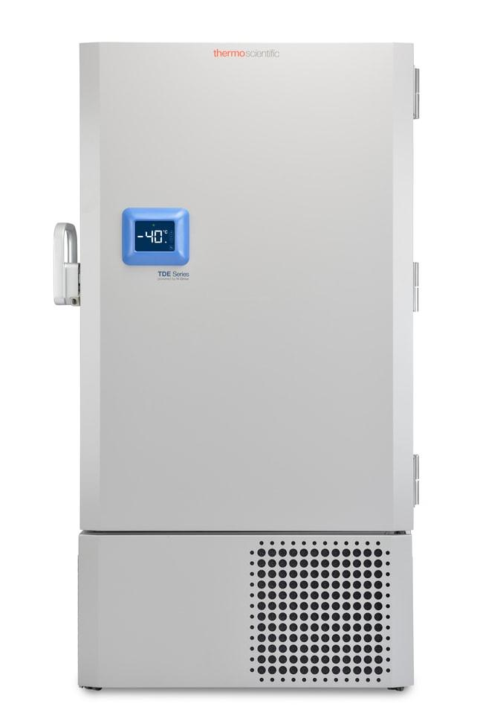

Figure 1: Working principal representation of -86 Ultra Low temperature Freezer



.

